**Functional Specification - Department of Labour Website (Internet)**

List of reviewers

|  |  |  |
| --- | --- | --- |
| Reviewer | Reference / Email / Contact | Comment |
| Business Analyst | Thabani Sibisi |  |
| IT Project Manager | Precious Mdlokovana |  |
| System Developers | Chunyiswa Ntozini, and  Saidarao Naradasu |  |
| Database Developer | Ingrid Roux |  |
| Business Project Manager | Lloyd Ramutloa |  |
| Lead Tester Quality Manager | Edmond Ntuli |  |

Document history

|  |  |  |  |
| --- | --- | --- | --- |
| Version | State / Changes | Date (yyyy/mm/dd) | Author |
| V.1.0 | Initial write | 2016/08/01 | Thabani Sibisi |
| V.1.1 | Review | 2016/10/20 | Johann Nel |
| V1.2 | Review | 2016/10/21 | Precious Mdlokovana |
| V1.3 | Review and additions from business | 2016/10/24 | Thabani Sibisi |
| V1.4 | Review and additions from business & QA - FINAL | 2016/10/28 | Thabani Sibisi |
|  |  |  |  |
|  |  |  |  |

PID request history

|  |  |  |  |
| --- | --- | --- | --- |
| PID # | Description | Requirements impacted/Changed | Date implemented |
|  | PID - Website Revamp v 2.0 |  |  |
|  |  |  |  |
|  |  |  |  |

**Document Approval Sheet**

*The signatures below signify acceptance by all parties of the terms and conditions as stipulated in this document.*

|  |  |  |  |
| --- | --- | --- | --- |
| **AGREED AND ACCEPTED**: | | | |
| **For Client (Communication):** | | | |
| *Name:* |  | *Name:* |  |
| *Position:* |  | *Position:* |  |
| *Signature:* |  | *Signature:* |  |
| *Date:* |  | *Date:* |  |
|  |  |  |  |

|  |  |  |  |
| --- | --- | --- | --- |
| **For IT:** | | | |
| *Name:* |  | *Name:* |  |
| *Position:* |  | *Position:* |  |
| *Signature:* |  | *Signature:* |  |
| *Date:* |  | *Date:* |  |

|  |  |  |  |
| --- | --- | --- | --- |
| **For QA:** | | | |
| *Name:* |  | *Name:* |  |
| *Position:* |  | *Position:* |  |
| *Signature:* |  | *Signature:* |  |
| *Date:* |  | *Date:* |  |

Contents

**Introduction** 9

**Purpose** 9

**Audience** 9

**Terms of reference** 10

**Non-Functional requirements and Solution constraints** 10

**Functional** 10

**Main Menu** 11

**Process and website layout** 11

**Dashboard** 12

**The layout** 12

**Related links** 14

**Header** 14

**User management** 29

**Search** 33

**News** 34

**Online Tools** 37

**Mobile devices and platforms** 37

**Subscription** 38

**User Feedback** 38

**Alerts** 42

**Data Migration** 42

**Internet Measures** 43

**APPENDIX: Adding users on SharePoint** 44

**APPENDIX A: Compensation Fund Landing Page** 46

**APPENDIX B: Public Employment Services Landing Page** 46

**APPENDIX C: Labour Policy and Industrial Relations Landing Page** 46

**APPENDIX D: Unemployment Insurance Fund Landing Page** 47

**APPENDIX E: Inspection and Enforcement Services Landing Page** 47

**Additional Information** 47

**Conclusion** 47

**Introduction**

Due to the increasing use of Internet technologies and the Department of Labour website, the requirement exists to enhance and increase the functionality of the departmental website. The increase in requirements is based on user and department specific requirements and also from the Communication directorate’s team who are constantly looking at ways of improving efficiencies in the management of the website. The current website is built on Open Source Zope/Plone framework. Plone 2.5.2, Zope 2.9.6, CMF 1.4.7, Archetypes 1.2.5, Python 2.4.5 Released November 26, 2004.

A project has been created to improve the Department of Labour website through the implementation of new features and to enhance some of the existing features. This document outlines the various features and functions required to achieve the directorate’s objectives of improving the Department of Labour website and to increase the utilization of the website through the implementation of these new features and capabilities.

There must be appropriate site architecture and technical infrastructure for the solution, this is in-line with the required for the Department of Labour website Internet. The redesign must encompass all the spheres that make up the Department (Compensation Fund (CF), Unemployment Insurance Fund (UIF), Labour Policy Industrial Relations (LP&IR), IES, and other entities of the department).

This document provides scope of the requirements of the Departmental website, details of the Departmental entities are provided as appendixes below (Appendix A - E) on a separate document.

**Purpose**

The purpose of this document is to describe in detail the envisioned website's intended capabilities, appearance, and interactions with users. This articulates what the system will do; with the focus being on externally-visible behaviours of the website, and not how it will be done.

The internal behaviours, or the “how”, are to be catered for in the technical specifications document.

**Audience**

This document is intended for IT stakeholders including the developers and Communication stakeholders. The IT developers and project managers have been identified above (*List of reviewers*) and the following stakeholders are crucial for the success of this project:

* Business Project Owner – Jani de Wet, Communication
* Departmental Entities
* Business Project Sponsor – Communication
* IT Enterprise Architecture – Johann Nel
* IT Governance – Bernie Meyburgh

Table : The following table depict the location of the documents

|  |  |  |
| --- | --- | --- |
| **Document Title** | **Author** | **Path** |
| Project definition | Thabani Sibisi | \\zadoluiffas03\PMO-SIS\DoL_PMO 2016\DoL Website Revamp\2_Analysis\ |
| Business rules, Landing Page | Thabani Sibisi | \\zadoluiffas03\PMO-SIS\DoL_PMO 2016\DoL Website Revamp\2_Analysis\ |

**Terms of reference**

The following terms of reference highlight what was agreed on during our weekly meetings on Mondays:

* E-mail is the agreed means of communication.
* Each entity will be represented by one or more member unless agreed by consensus with all other members.
* Members may attend whenever possible so as to maintain the integrity of the meeting.

**Non-Functional requirements and Solution constraints**

Performance

* Response Times
  + The solution must conform to the standards specified in the performance matrix (*Appendix*) depicted below.
* Availability
  + The website must be 99.99% availability through the network facilities onto the internet. Customers should be able to access the website at any time of day.
* Architecture
  + The framework must also support the solution/website.
* Security
  + The website must use secure sockets (SSL) in all transactions that include any confidential customer information. The website must notify the user after a period of inactivity that they will be logged out.
* Compatibility: *Please refer to business rules*.

**Functional**

The functional requirements provide brief items below to be performed, please refer to the business rules for detailed requirements.

* Search functionality
  + The website must allow the users to enter the search text on the screen, please refer to “*Search below, Figure 27*”.
* Usability
  + The website must provide a uniform look and feel between all the web pages, and different devices.
* Content
  + The Authorised user/s must be able to add, modify the content. This must apply to the Main menu (Authorised user must be able to modify the Main menu).

**Main Menu**

The menu is structured in this format:-

**Home | About Us | Contacts | Online Tools | Media Desk | Documents | Tenders | Vacancies**

The navigation must change colours to indicate the current section and when you mouse over/hovering over. The title bar/heading and the breadcrumb must have the same colour palette as the menu.

Subheading (H2, H3) will also be on the same colour as the H1/ main section colour.

The news must keep the black colour font. For each news item there must be an option to share the news on social media, an optional option to print and email the news article page. The information on each page must be editable by the authorised user/administrator.

The colours used are the recommended colours as per the Coat of Arms.

Figure : The following image depicts the colours to be used on the main menus of the Departmental website

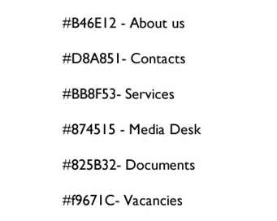

**Process and website layout**

The process provides details of how the user navigates throughout the website and how each page is linked. The website will have all the main menu, footer, links linked together for pagination.

The image below provides details of the pages available on the website and the links.

Homepage – Denotes the main menu/landing page of the Departmental website, to be described as “Home”.

About Us, Contacts, Online Tools, Media Desk, Documents, Tenders, Vacancies – Denotes the main menu pages of the Departmental website.

Each of the above main menu page will have its own page with content that is editable by the authorised user.

Figure : The following image depict the processes of the Main menu pages of the Departmental website

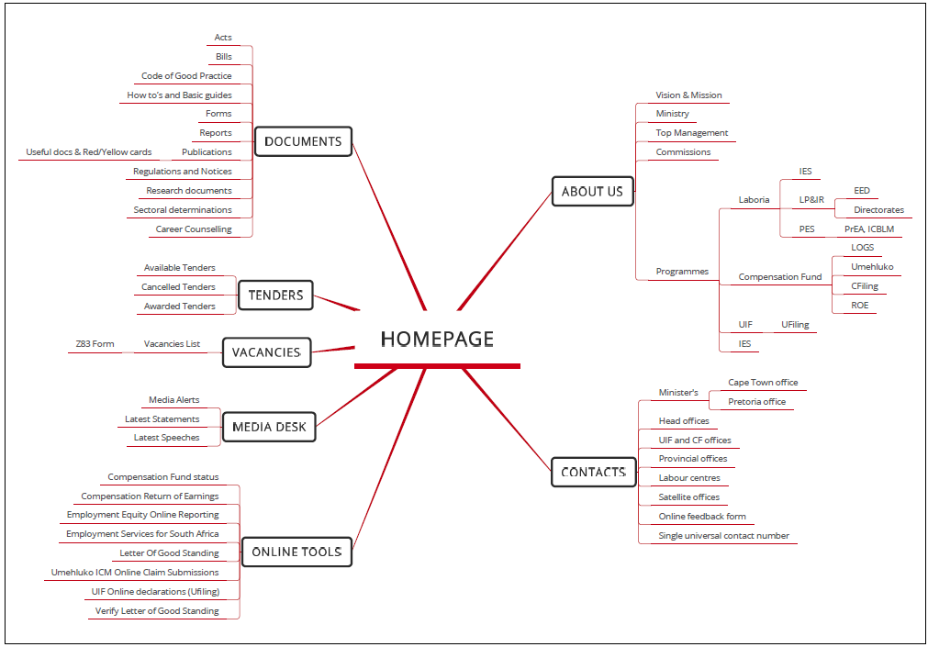

**Dashboard**

The Dashboard must be easy, simple and intuitive (adopt the use of simple graphs, pie and bar charts) as they are much simpler to understand. The Dashboard shall be used as a data visualizing tool. This feature is only accessible to the Administrator for analytics, more details on this item are on ***Internet Measures*** and screen-images will not be part of this document but user manual.

**The layout**

There are various layouts which have been envisaged of the website to cater for the website which are required. The requirements are as listed below:

**Home / Homepage / Landing page**:

Figure : The following image depict the proposed landing page of the Departmental website

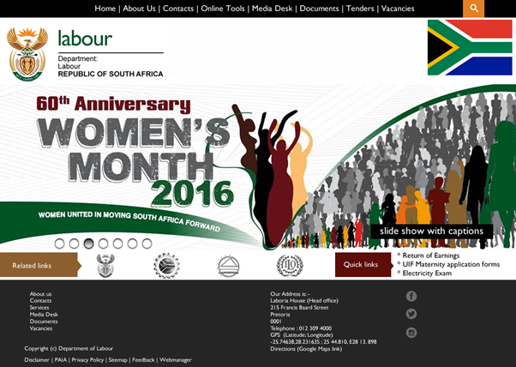

The layout above on “*Figure 3*” has:-

* Main Menu (Top background colour is black with menu written in white font),
* Header (Below the main menu – Corporate branding design of the Coat of Arm or as per the proposed design),
* Photo Slideshow / Banner (Below the header as per the proposed design),
  + Animation - predetermined path, like a circle must allow a click to the next image or wait for it to load. Effect must change after 10 seconds to the next available image.
* Related and Quick links (Below photo slideshow as per the proposed design), and
* Footer (This has Menu, footer, copyright, social media and address written in white font or as per the proposed design)

Figure : The following image depict the Quick links



The website must have a maximum of 6 - 7 quick links on the home page, quick links display frequently used or popular resources of the website using the intelligence to flag and display the items. Quick links may display sections of the website. The Administrator must be able to add on the quick links.

**Related links**

The Labour website shall provide other useful links of associated with the department, the Department of Labour has the following useful information:-

* The South African Government Online
* National Economic Development and Labour Council
* The Commission for Conciliation, Mediation and Arbitration
* International Labour Organisation

All these links are captured on the layout of the proposed Department of Labour website as “Related links”, *Figure 3*. The related links (hyperlink icons) must be a transition effects/slideshow on the page to display all the available links. The slideshow must stop upon mouse over/hoover and display a full name of the icon and not abbreviation.

**Header**

On home page and all the other pages the header must be dynamic menu to allow Admin to modify it (if the site scrolls down the menu must be visible and not move), this will not change with the clicks as a photo slide but will have matching image for each menu item. The scroll must be as per the recommended technology used i.e. it can be from left to right or right to left or fade and this applies for the landing page banner.

Below the main menu there is a “Coat of Arms” on the left hand side and the “South African National Flag” on the right hand side, this must be as stipulated within the corporate branding of the Department of Labour.

Below the Coat of arms and the South African National flag there is a dynamic image with current, upcoming event and or advertisements with 6 different slides. This must be editable by the Webmaster when uploading new content as and when required. Details are on “*Figure 1*”.

**About us**:

Figure : The following image depicts the view of the mission, vision & values of the ‘About us’ Ministry page

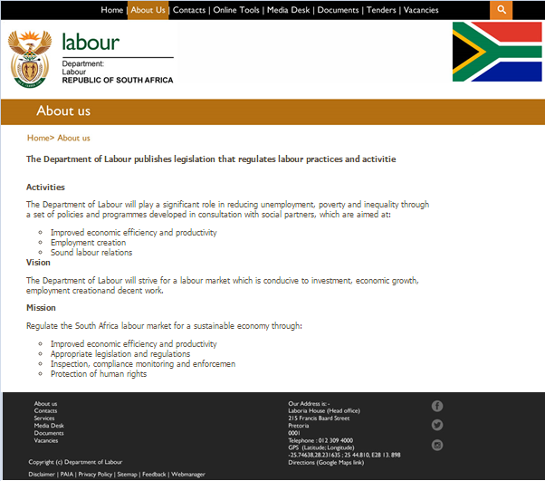

Figure : The following image depicts the layout of the ‘About us’ Ministry page

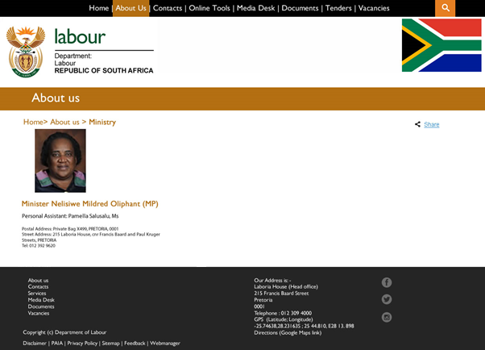

*Figure 6* must have image of the Minister with Minister’s name, name and surname of personal assistance to the minister and physical address details.

The “*Top Management”* on “*Figure 7*” must have:-

* Departmental management
  + Picture for each official,
  + Name & Surname of the official,
  + A brief description for each official of their job,
* Personal Assistant
  + Name & Surname of the Personal Assistance (PA)
  + Telephone number / Mobile number,
  + Fax number, and
  + Email address of the PA (e.g. Zodwa Mbikwana - PA)

The “Top Management” details must be presented in a tabular form with the different Business units or programmes available at Departmental, *Figure 7*.

Figure : The following image depicts the layout of the ‘About us’ Top management with Provincial details

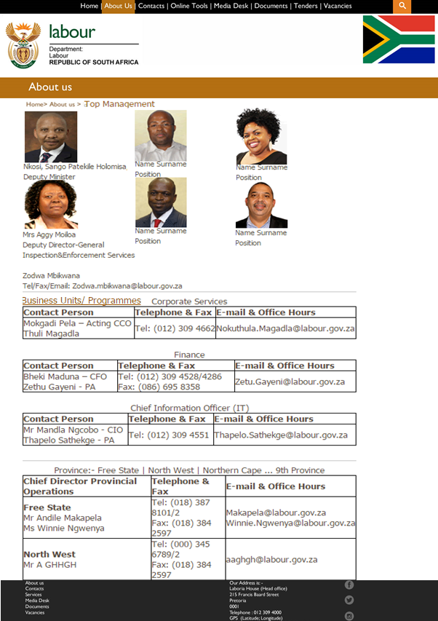

Figure : The following image depicts the programmes page within the Departmental website

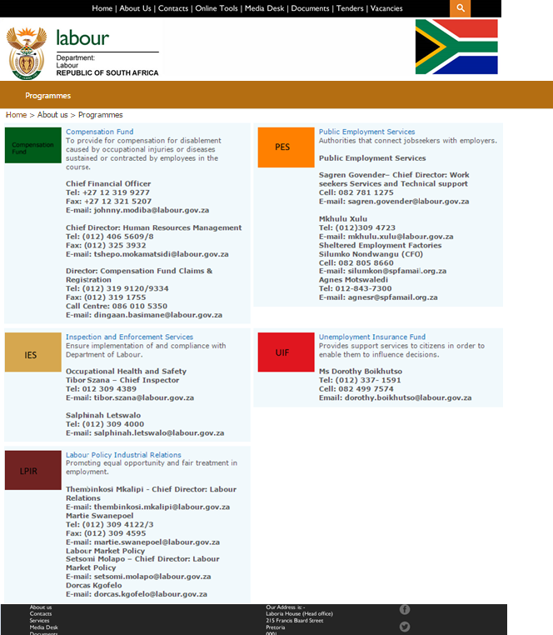

**Contacts**:

Figure : The following image depicts the main page of the contacts

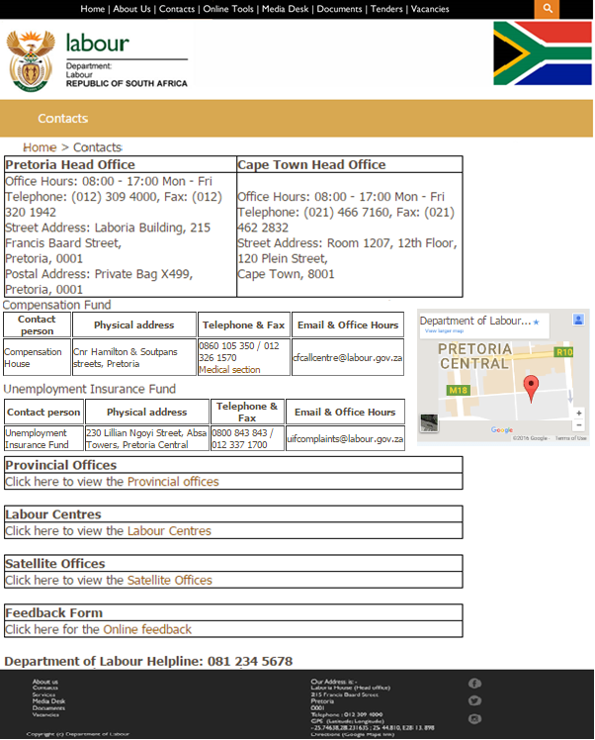

When the user clicks “Provincial Offices” the website must open a page with the list of all the available Offices, *Figure 9*. Below is the list of the Provincial offices:

* Eastern Cape, Free State, Gauteng, KwaZulu-Natal, Limpopo, Mpumalanga, North West, Northern Cape, Western Cape

When the user clicks “Labour Centres” the website must open a page with the L/C, in the form of *Figure 9*. Below is the list of the Labour Centres within Provinces:

* Eastern Cape, Free State, Gauteng, KwaZulu-Natal, Limpopo, Mpumalanga, North West, Northern Cape, Western Cape

When the user clicks “Satellite Offices” the website must open a page with the Satellite offices, in the form of *Figure 9*. Below is the list of the Satellite Offices within Provinces:

* Eastern Cape, Free State, Gauteng, Mpumalanga, Western Cape

When the user clicks “Online Feedback” the website must open a page with the L/C, in the form of *Figure 32*.

* Online Feedback Form

Figure : The following image depict the contacts page for the Provincial Offices

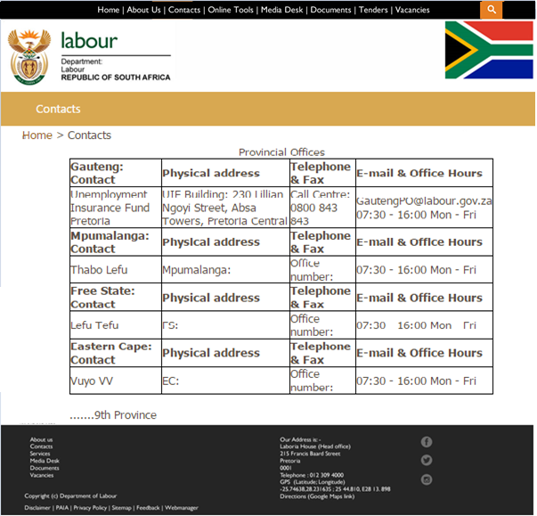

The page above provides a summary of the provinces but the solution must display all the provincial offices i.e. 9 Provinces.

**Online Tools**:

Figure : The following demo image depicts the Online Tools page

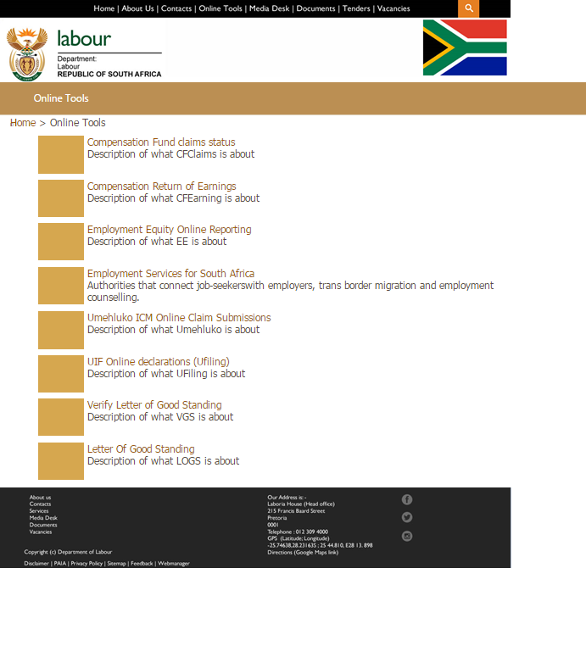

This page will display all the available and published online tools, the online tools represent features of all the public facing systems that the user/s can interact with. A correct description must be provided for each of the items.

**Documents**:

Figure : The following image depicts the view of the documents page

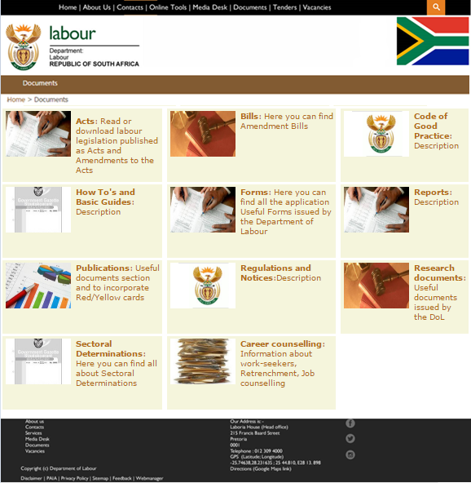

This page will display all the approved documents by their directorate in PDF format only. Users must be able to fill-in some converted PDFs to interactive fillable form. E.g. EEA2, EEA4.

The documents must be structured per Entity/Directorate inside each link where applicable, this will make is easy to manage the information. E.g

**Act:**

* Unemployment Insurance Fund
  + Amended Unemployment Insurance Act (PDF file)

**Tenders:**

Figure : The following demo image depict currently advertised tenders

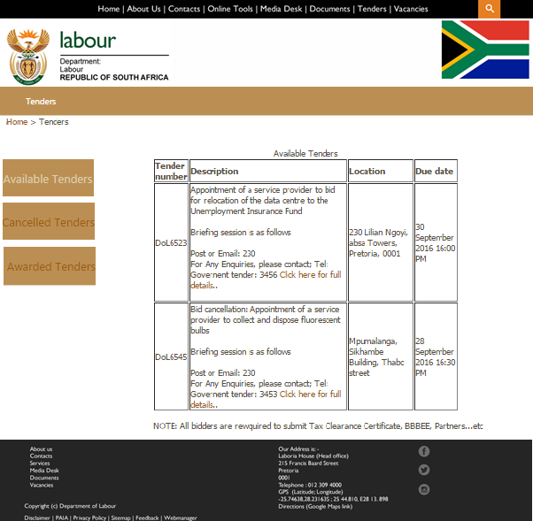

The user must click the hyperlink “Click here for full details/Bid/Cancelled” Tenders to view and read full details of the requirements on a PDF. There must be a brief description of the tender details on the screen before the user can click to read the advertised PDF.

As the data increases exponentially over time, there must be a functionality to archive the tenders in the form of Quarterly and year e.g. Jan – Mar 2016.

Figure : The following demo image depict cancelled tenders

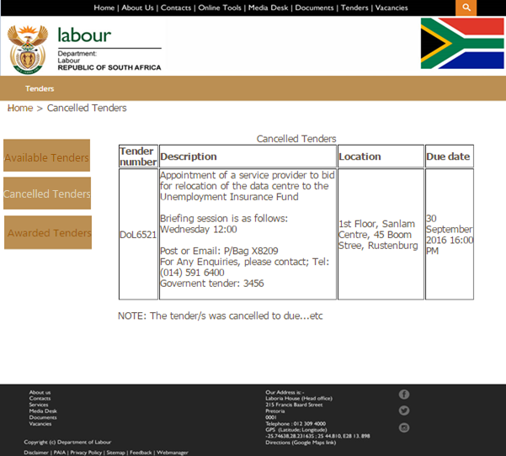

Figure : The following image depict the PDF after user clicks the hyperlink “Click here for full details/Cancelled tender”

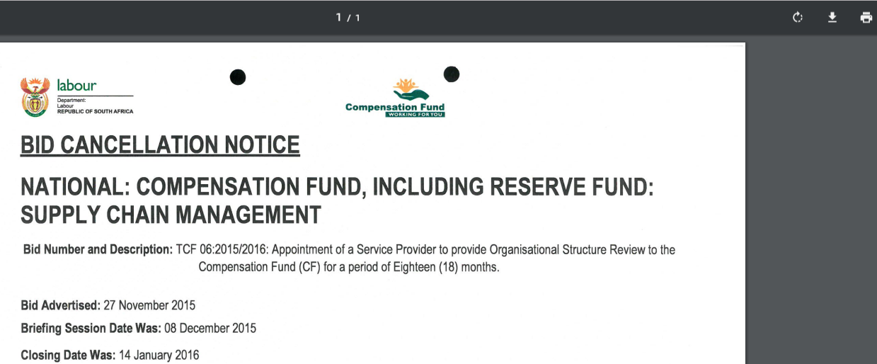

The PDF must provide full details of the Tender/Bid, allow the user to save it to chosen device.

Figure : The following demo image depict awarded tenders

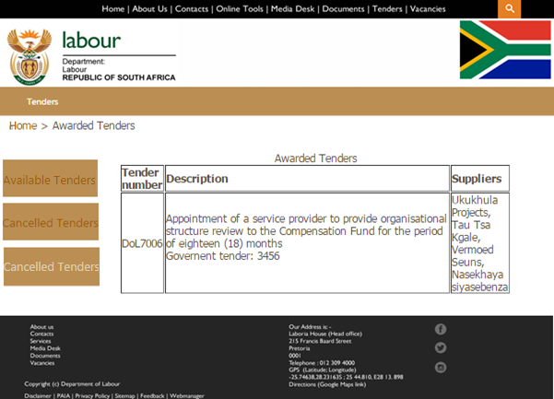

The above image gives details of all the awarded tenders with details of the information captured per tender or item advertised.

**Vacancies**:

Figure : The following image depicts the view of the vacancies page

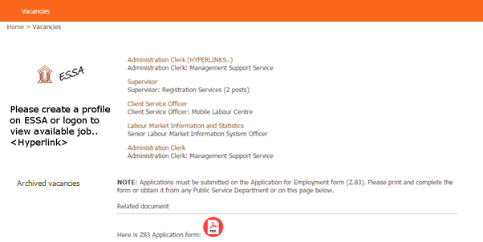

Expired vacancies must be archived on the “Vacancies” page, when a user clicks the link it must give a list of all the expired vacancies in Month and Year e.g. January 2016, February 2016.

Figure : The following image depicts the overview of the job after clicking the job on *figure 17*

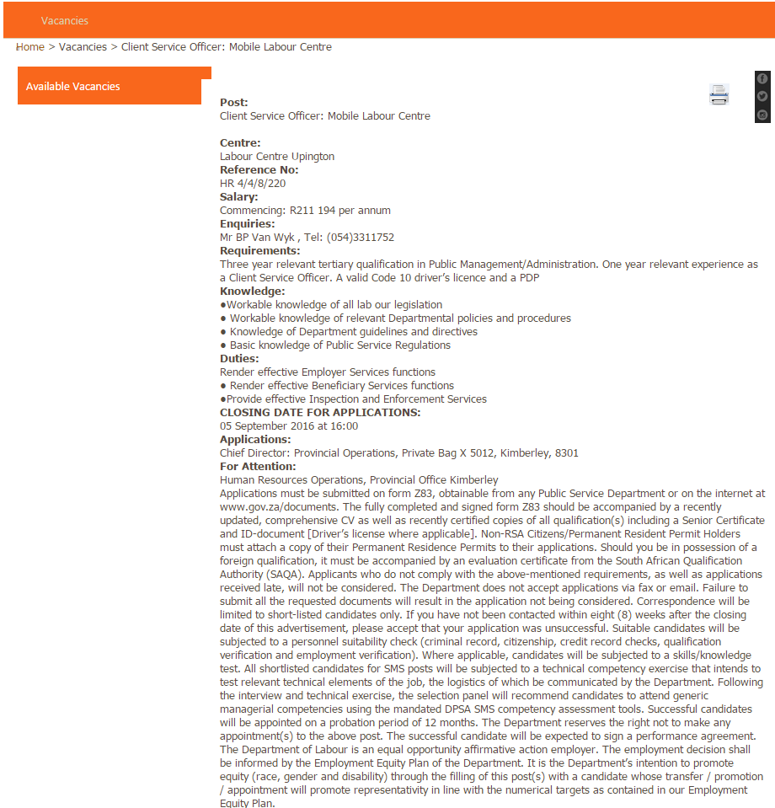

* 1. **Social links**
* Facebook
* Twitter
* SoundCloud

The Social links are as described on the proposed main page of the Department of Labour website.

* 1. **Footer**

Copyright © Department of Labour

**Disclaimer | PAIA | Privacy Policy | Sitemap | Webmanager**

* 1. **Colour palette**

Figure : The following image depicts the colours of the branches of the Departmental website

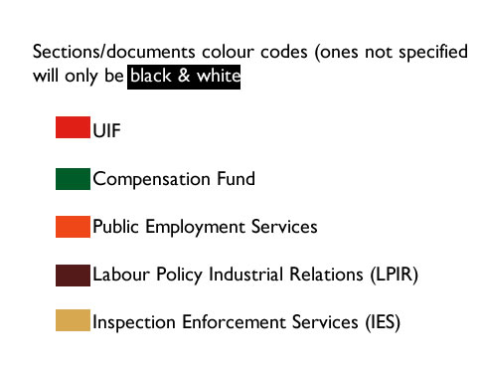

The above colours must be used for all the documents and sections (E.g. Structure) colours will be used so that users can easily identify a UIF document or form.

Colour codes for the branches

Table : The following image depicts the colours to be used for the different programmes of the Departmental

|  |  |
| --- | --- |
| Hex Colour Code | Programme |
| #e01f16 | UIF |
| #005c29 | CF |
| #ee4818 | PES |
| #541a19 | LP&IR |
| #d6a74f | IES |

The colours are not distinctive when translated into English e.g. the colour #ee4818 hex colour red value is 238, green value is 72 and the blue. Colour code gives the best description.

* 1. **Font**

Here are the fonts to be used on the Cascading style sheet (CSS), only one font can be adopted throughout the design of the website. The font size of the website must be at minimum, the browser default size of 16 pixels (100%).

Figure : The followig image depicts the fonts to be used on the CSS for the design of the Departmental website

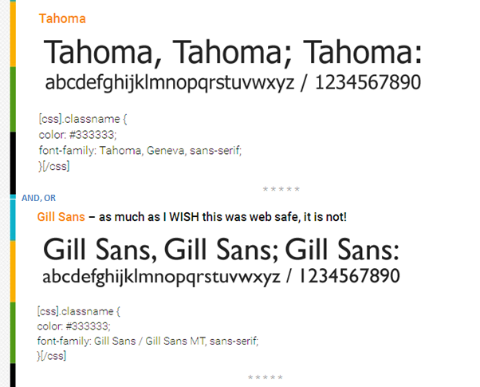

* 1. **Body Banner (Photo Slideshow)**

Please refer to “***Process and website layout***” for the structure and design of the image. The image consists of Adverts, upcoming events or imbizo from the Department of Labour. The photo slideshow effect duration is both manual & systematic which uses the latest HTML & jQuery to change the image. The user may click on the next image by clicking the “radio button/circle” below, this photo slideshow must be managed according to the number of graphics displayed on the homepage.

Figure : The following image depicts the photo slideshow banner



* 1. **Site Maps**

The Labour website must have mechanism of the working sitemap listing all the links and sub links available on the website.

**User management**

The Labour website users will be stored and managed from the Active Directory.

* 1. **Register new user**

The user database can be time consuming to maintain, especially when there are some problems with the current generation of passwords. The user must be able to enter personal details (name, telephone, and email address).

**Future proposal**: With the view of the Single sign on/One Departmental view the public must have access to the website and logon using their ID numbers as username.

* 1. **Auto-generate password**

When the new user registers on the Internet, the passwords are automatically generated when the account is created and sent to the user via email.

Users are now required to use their ID numbers (proposed “Single-Sign-On”) as a username, and password will be generated by the system/chosen by the user.

The password must be a combination of letters and numbers, generated randomly by the system. The system will provide the password reminder functionality in case the user has forgotten the password.

The user must be able to use the same username and password to logon to any device used and the screen must adjust accordingly (Desktop, PC, iPad, Tablet, Android, iOS, Windows mobile). If the email already exists, the user shall be notified accordingly and redirected to “*Forgot password*”. The password will be sent to the user’s email address.

Figure : The image depicts logon screen of the Departmental website

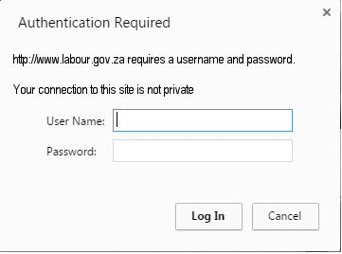

* 1. **Existing users**

The users shall use their username and password to gain access to the Labour website. Users shall see only the content as matching to their roles. There should also be a welcome section across the page that tells a user the last time that she/he had logged in and displays the user’s first name. The Administrator and authorised users will logon using their username and password

* 1. **Audit trails**

The Labour website must make provision for all the login sessions and record each attempt. Also mention audit trails. The Labour website must redirect the user to “Forgot password” if all three attempts have been exhausted. Dormant profiles must be managed and dormant rule be exercised in such.

Figure : The image depicts process flow for managing user profile by Admin



The above image depicts the process users and administration will have to follow in order to add and manage user profiles in the system. The following are the key aspects of the process:

1. Users will register and update their profiles
2. Administrator/s will be able to manage;
   * The dormancy rules for the user profiles
   * Request a report on dormant profiles
   * Delete profiles which are dormant
3. The system will check for dormant profiles
4. The system will automatically delete dormant profiles after notifying the users
5. The system will automatically generate usernames and passwords

Figure : The following image depict the Audits for the broken links

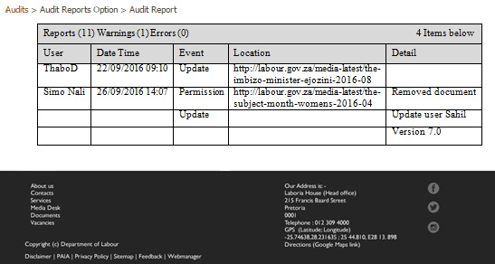

The above image display all the broken links on the website with the action date of the event, these may be broken on different pages. User friendly messages must be displayed instead of an exception handler.

* 1. **User Matrix and Groups**

The user accounts and Groups on the Department of Labour website will be managed by the Active Directory. The AD will keep the information of all the users, audit logs will be stored on the database providing details of the successes and failures for all the users attempting to logon to the website with dates.

The audit table must have the following columns:-

* Login Attempt, (Attempted) Username, (Attempted) Password, Status (Pass/Fail), Group, and Datetime.

This must be provided in a tabula form with rows and columns.

User Groups on the Department of Labour website:-

* **Visitor** - A special group that gives guest users access to a specific list, without giving them access to the entire site.
* **Contributor** - Allows a user to interact with Web Parts and lists and document libraries.
* **Reader** - Allows a user to view items in lists, folders and document libraries, view pages in the site, and create a site.
* **Online** – *Proposed single sign on online users*.
* **Member** – Newly created users. They can’t create content, unless given permission
* **Web Developer** - Allows a user to customize the website using HTML tools or web page editor compatible with Windows SharePoint Services.
* **Administrator** - Allows a user to have complete control or all permissions over a website. Admin has ownership of the site group can configure settings, manage users & groups, and view analysis data.

If the user belongs to none of the mentioned groups, it must be noted as “Unknown”.

Figure : System sequence diagram for login validation



**Search**

The search must not be case sensitive and should bring up all the information matching the inputted search criteria, this must be user friendly with the use of search engines crawling and indexing site properly (jQuery, configured content search web query, with Auto-text is a portion) and auto-complete text as the user is typing. The Department of Labour website must be searchable from search engines.

Figure : The following image depict search screen on the Labour website with auto-complete text

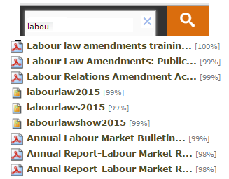

The website must have Frequently Asked Questions (FAQ) to assist the users in finding information on the directorates, this can be managed using a ListView Web Part or just link directly to the main view.

**News**

The “News” area will have a summary of the news page as shown in the image below with an option to read more. Clicking on any of the topics will open the news article. Clicking on Back or Home option should take the user back to the home page. Clicking on the View more option, the user will be taken into the full news page where the user can choose to view all the articles. There should be an option to take back the user to the Labour website home page. The news shall be added using an Editor / an adaptation of Microsoft editor tool.

Figure : The following image depicts the view of the media desk page

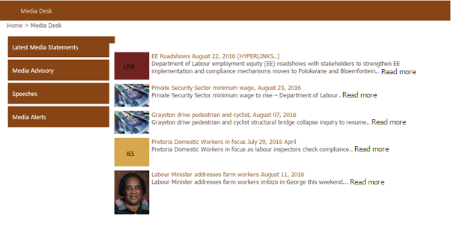

* 1. **News Archive**

The system will display five recent news articles on the news page and archive the old news in a format of a month and a year (MMYYYY), and display them in a descending order from the highest number to the least. Different news will appear here including news of latest judgment from the courts pertaining to the entities of the Department. This is how the component of the webpage will look like:-

Figure : The following image depicts the view of the archived news

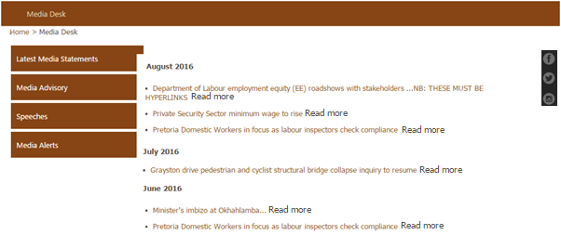

* 1. **Create News or Content**

The Content editor or Administrator can manage the content on the Labour website, this is the process followed for amending an article in this case we provide details of publishing the content. The Administrators, Managers, Content creator will be managing the content and making sure that it is meaningful to the organizational objectives and users. Articles or News will be created by the authorised user on the live website.

Figure : The following image depict screen of adding a news article

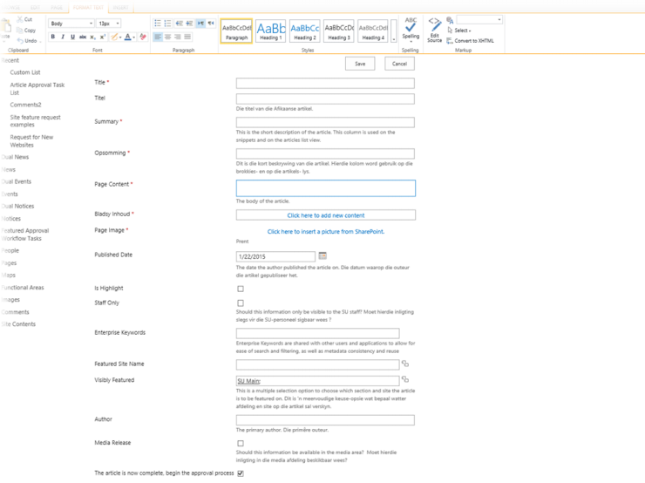

Figure : The following demo image depict the process flow of publishing content

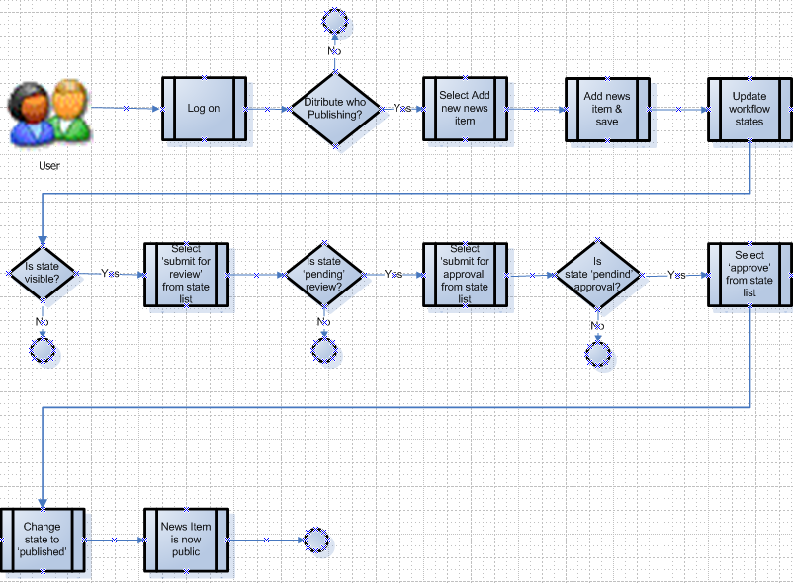

**Online Tools**

The “Online Tools” option will show the details of the available online tools to the user. The user must be able to view all the available services. Online Tools page should have a back or home option that allows the user to go back to the Labour website home page.

The following is a list of the online tools available to the users:-

* Employment Equity
* Employment services of South Africa
* Letter of Good Standing
* Compensation Fund claims status
* UIF online declarations
* SETA grants disbursement
* Umehluko ICM Online Claim Submissions
* Compensation Fund Return of Earnings Submissions

**Mobile devices and platforms**

The Labour website solution must be compatible with all the different mobile devices (Android, iOS, Tablet, iPad and Windows) and tablets of different platforms. The solution must be able to adjust to different screens used to access it. Details of the device used to access the website must be stored as part of analytics. There must be a geolocation enabled for users that are searching for a nearest Labour centre on the website.

**Subscription**

The users should be allowed to subscribe to the following applications where necessary as long as valid email address is captured under the preferred options:-

* Employment Equity
* Employment services of South Africa
* Letter of Good Standing
* Compensation Fund claims status
* UIF online declarations
* … etc

When there are any changes to the application, an email will be sent to the user’s inbox notifying the user of the changes for the user to act on those changes.

**User Feedback**

The Labour website shall provide the ability for users to send via a form inquiry. The inquiry provided must be channelled automatically to the relevant branches/entities i.e. CF, PES, IES, LP&IR, UIF, and Laboria house. The feedback will assist in keeping track of what users raise and be used as a tool to monitoring the use of the website.

The information gathered will be used to assess how users are taking advantage of the solution, a warning on the system to identify the capabilities that can help the Department of Labour achieve its business objectives.

The following fields must be compulsory and noted with a red asterisk:

* First name,
* Surname,
* Email address,
* Province,
* Labour office,
* CAPTCHA, and
* Comments

Figure : The following image depicts the online feedback form



Figure : The following image depicts Disclaimer page for the footer

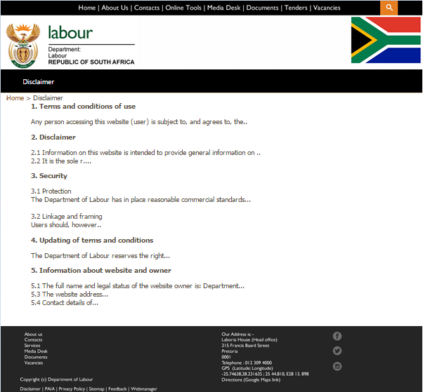

The Webmanager link of the footer when clicked must open Labour Ministry, *Figure 7*.

The Feedback link of the footer when clicked must open the online feedback form, *Figure 32*.

Figure : The following image depicts PAIA page for the footer

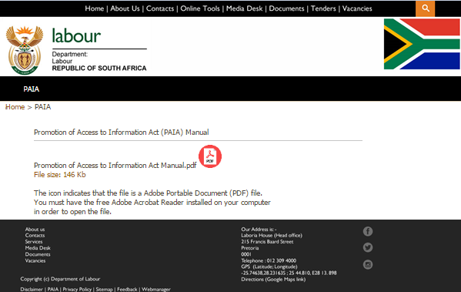

Figure : The following image depicts the privacy policy page for the footer

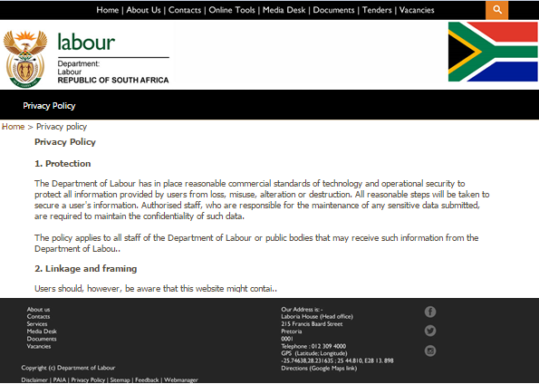

**Alerts**

This feature allows the Administrator to receive an e-mail notification when list items are change.

Figure : The following image depicts e-mail notification

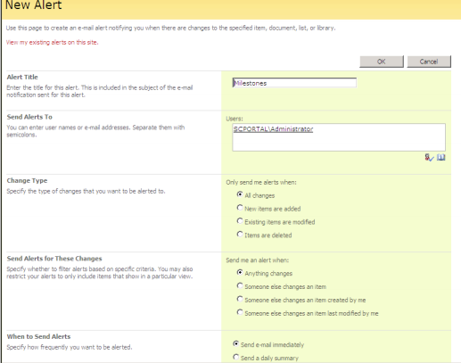

**Data Migration**

As part of Business catalyst support there must be migration of the files and data (content) from the source site (current website) to the destination site (Revamped website). Data migration can be a complex process, especially with different technologies and the features. Importing the current website can be challenging, because the system will not copy all the source website's files.

There are different options to be exercised when migrating a website such as custom tools for grabbing content from the old website, export content from the initial database in .csv files, analyse the URLs which should be practised when moving the content.

The folder structure from Zope/Plone to Microsoft technology will be different and that must be considered.

After the data and files have been uploaded on the proposed/new website files with the database, the next step will be to test the functionality of the website.

**Internet Measures**

The key measures are required to track the trend of the Labour website. This will be available to the authorised administrator for analysing the trends and usage of the website.

Table

|  |  |
| --- | --- |
| Metric | Objectives |
| Number of users and number of unique users over time | The uniqueness of the trend. |
| Usage by time | Times the site is mostly used. |
| Page Hits | Provide details of pages that should be archived or deleted if there is a need. |
| Time spent on Page/Site | Provide details of the important pages/features. |
| Broken pages or links | Fixes can be implemented on the pages. |
| Most Viewed & downloaded Documents | Provide details of features that are not being used. |
| Most Viewed Pages | This gives an indication of how content is being used, business will use such in making decision. |
| Database growth | Provides a way to spot trends in database growth over time. |
| Number of regular Users | Growth of users from launch to stability.  Regular visitors to the website. |
| CPU and Memory usage | Provides means to monitor performance at all times to plan capacity over time and by time of day. |
| No Results on search, Frequently searched strings | Provides details of the content that the users are looking for. |
| List of updated pages |  |

The solution must provide a proxy to view some of the interaction mentioned on the table above for content. This will be used as part of the analytics and reports available to the authorised administrator.

**Abbreviations**

Table

|  |  |
| --- | --- |
| Departmental | Department of Labour. |
| PES | Public Employment Services. |
| EED | Employment Equity Directorate. |
| AD | Active Directory. |
| LP&IR | Labour Policy and Industrial Relations. |
| iOS | An operating system used for mobile devices manufactured by Apple Inc. |
| Android | An open-source operating system used for smartphones and tablet computers. |
| Windows mobile OS | A mobile operating system for smartphones and mobile devices from Microsoft based on the Windows CE kernel and designed to look and operate similar to desktop versions of Microsoft Windows. |
| LOGS | Letter of Good Standing. |
| IES | Inspection and Enforcement Services. |
| UIF | Unemployment Insurance Fund. |
| PAIA | Promotion of Access to Information Act. |

**APPENDIX: Adding users on SharePoint**

The above image provides the process to be followed when approving or declining a user request to be granted rights on the website. Description is on the process.



The above image provides details of adding / deleting a user on the website.

**Performance matrix**

Table 5: The following image depict the Performance Matrix

|  |  |  |  |  |  |  |  |  |
| --- | --- | --- | --- | --- | --- | --- | --- | --- |
| **Performance requirement** | **Off-Peak hours** | | | | **Peak hours** | | | |
|  | **Average**  **Response**  **Time** | **Maximum**  **Response**  **Time** | **Average**  **Turnaround**  **Time** | **Maximum**  **Turnaround**  **Time** | **Average**  **Response**  **Time** | **Maximum**  **Response**  **Time** | **Average**  **Turnaround**  **Time** | **Maximum**  **Turnaround**  **Time** |
| User Authentication interface | 2 seconds | 5 seconds | 4 seconds | 7 seconds | 3 seconds | 5 seconds | 5 seconds | 9 seconds |
| Password generation | 3 seconds | 8 seconds | 5 seconds | 13 seconds | 4 seconds | 8 seconds | 5 seconds | 15 seconds |
| Submit/Save article | 3 seconds | 8 seconds | 5 seconds | 14 seconds | 4 seconds | 9 seconds | 5 seconds | 15 seconds |
| Pagination | 2 minutes | 4 minutes | 3 minutes | 5 minutes | 3 minutes | 6 minutes | 3 minutes | 7 minutes |

**APPENDIX A: Compensation Fund Landing Page**

The look and feel of the CF landing page must be the same as the proposed Departmental website with the CF menu and content.

Please refer to:

* *UC-Departmental_001_Landing Pages* for CF landing page, users will access this by clicking “About Us 🡪 Programmes”

**APPENDIX B: Public Employment Services Landing Page**

The look and feel of the PES landing page must be the same as the proposed Departmental website with the PES menu and content.

Here are the entities within PES:-

* Career Counselling
* E-Government
* TV Kiosk
* Private Employment Agencies (PEA)
* Employment Services of South Africa (ESSA)
* Sheltered Employment Factories (SEF)
* International/ Cross Border Work Visa Application information (ICBLM)

Please refer to:

* *UC-Departmental_001_Landing Pages* for PES landing page, users will access this by clicking “About Us 🡪 Programmes”

**APPENDIX C: Labour Policy and Industrial Relations Landing Page**

The look and feel of the LP&IR landing page must be the same as the proposed Departmental website with the Directorate menu and content.

Here are the entities within LP&IR:-

* Employment Equity Directorate
* Collective Bargaining
* Employment Standards
* International Relations Chief Directorate
* Labour Market Policy chief Directorate

Please refer to:

* *UC-Departmental_001_Landing Pages* for LP&IR landing page, users will access this by clicking “About Us 🡪 Programmes”

**APPENDIX D: Unemployment Insurance Fund Landing Page**

The look and feel of the UIF landing page must be the same as the proposed Departmental website with UIF menu and content.

Please refer to:

* *UC-Departmental_001_Landing Pages* for UIF landing page, users will access this by clicking “About Us 🡪 Programmes”

**APPENDIX E: Inspection and Enforcement Services Landing Page**

The look and feel of the IES landing page must be the same as the proposed Departmental website with Directorate menu and content.

Please refer to:

* *UC-Departmental_001_Landing Page* for IES landing page, users will access this by clicking “About Us 🡪 Programmes”

**Buttons**

Submit/Save/Ok Button – It must store the captured information to the database and stay on that current page.

Next Button – It must store captured information on the database and move to the following page.

Back Button – It must return back to the previous page.

Clear Button – It must remove all the filled-in information

Cancel Button – must not commit or store the changes but retract.

**Additional Information**

The following documents are provided separately and forms part of this Departmental site revamp:

* *Business rules, User matrix and Entities landing pages*.

**Conclusion**

As this document mentioned, the Department of Labour website revamp is designed specifically for the internal users, all the different entities of the department and public. The system realizes the goal of measuring the effectiveness of different devices, browsers and technologies by using the latest technology available. Finally, the system is widely expected to be user-friendly, error-less and stable.